2023 Call for Poster Abstracts

The annual conference program planning committee & student sub-committee of the Arizona Geriatrics Society (AzGS) invites you to submit poster abstracts for the AzGS annual fall conference on October 21, 2023 at the University of Arizona College of Medicine in Phoenix, Arizona.

Educational Needs: The society welcomes submissions on all topics pertinent to the field of aging, including but not limited to basic research, clinical research, quality improvement, medical education, patient safety, high value care, clinical vignettes, and many more. We highly encourage presentation of ongoing work in the state of Arizona.

Target Audience: The conference is designed for medical students, physicians, physician assistants, nurse practitioners, nurses, pharmacists, social workers/case managers, and other professionals practicing in the field of aging.

Physicians, residents, medical students, and others passionate about elder care, nursing home, assisted living, community service, and research in the field of aging are highly encouraged to present their ideas and work.

How to Submit: To submit a poster for the 2023 Annual Fall Conference, please look at the instructions below. The deadline to submit is October 8th, 2023.

Please create a template for your poster and send it to the poster review committee at the email address below. A sample template is shown in the instructions below. The poster review committee will review all posters and approved posters will get to present during the conference poster session. All posters that are accepted will need to be printed and will be displayed at the conference.
All participants will be notified of their acceptance by October 14th, 2023.

Please send your submissions to info@azgs.org with your name and education level in the subject line.

Questions? Contact the student society at info@azgs.org

Instructions:

Posters should be:

Printed: Single sided (Example: Scientific Posters)
Orientation: Landscape
Size: Standard (Poster size is Width 48” x Height 36”)
Sections: Posters shall include all of the below sections, and an additional acknowledgement section should be included. If appropriate, posters should include pictures, tables, and/or graphs.

Posters should be structured to include the following sections:

- Title and Authors
- Background/Need: The identified health need and some of the pertinent epidemiology/policy history.
- Community Partner: Information about your community partner (mission, program areas, how your project fits with these) if applicable.
- Project Description: Description of your project, objectives, major activities and analytic approaches, if appropriate.
- Outcomes: Main results and outcomes, milestones, impact(s) on the community partner/community.
- Discussion/Lessons Learned: A reflection on your role (as someone who displays an interest in aging) in engaging with your community partner and implementing your project and project challenges.
- Recommendations: Next steps for sustaining and disseminating the project, ideas for future projects to build on results and additional needs that were identified.
- Acknowledgements (if applicable): Recognize project mentors and funders (e.g. Medical Scholars, Valley Foundation). Posters should not include any confidential information or any information that your community partner has not deemed public information.

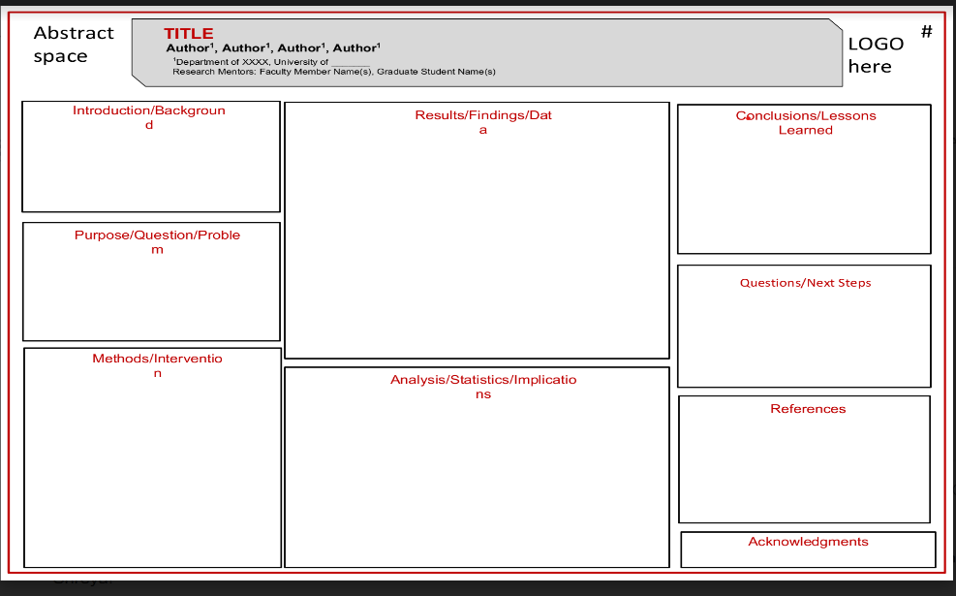

Sample Poster

